**Stage 3 Report**

**Achieving Proactive Cybersecurity with SOC and SIEM Integration**

**SECURITY OPERATIONS CENTER (SOC)**

A Security Operations Center (SOC) is a centralized unit within an organization that is responsible for monitoring and defending the organization's IT infrastructure, networks, and data against cybersecurity threats. The SOC plays a crucial role in ensuring the security and integrity of an organization's digital assets and preventing, detecting, and responding to security incidents.

**Key Functions of a SOC:**

Monitoring and Threat Detection: The SOC continuously monitors the organization's systems and networks for signs of suspicious or malicious activity. It uses various security technologies, such as Intrusion Detection Systems (IDS), Intrusion Prevention Systems (IPS), Security Information and Event Management (SIEM) tools, and advanced threat detection solutions to identify potential security threats.

Incident Response: When a security incident is detected, the SOC initiates an incident response process. This involves investigating the incident, determining its severity and impact, containing the threat, and implementing measures to remediate and recover from the incident.

Threat Intelligence: SOC analysts utilize threat intelligence feeds and sources to stay informed about the latest cybersecurity threats, vulnerabilities, and attack techniques. This knowledge helps the SOC in better understanding potential risks and adjusting security measures accordingly.

Vulnerability Management: The SOC collaborates with other IT teams to manage vulnerabilities in the organization's systems and applications. It identifies and prioritizes vulnerabilities and works with relevant stakeholders to apply patches and remediate security gaps.

Log Analysis and Forensics: The SOC reviews and analyzes logs and security events to identify patterns, potential security incidents, and indicators of compromise. In cases of a security breach, the SOC conducts forensics investigations to determine the root cause and extent of the incident.

Threat Hunting: The SOC actively seeks out hidden threats or indicators of compromise that may not be readily apparent in standard security logs. This proactive approach helps identify potential threats before they cause significant damage.

Security Awareness and Training: The SOC provides security awareness training to employees, educating them about common cybersecurity threats and best practices to reduce the risk of human error leading to security incidents.

Continuous Improvement: A well-functioning SOC continuously assesses its processes, tools, and procedures to improve its capabilities and response effectiveness. It learns from past incidents and adjusts its strategies to stay ahead of emerging threats.

**SOC Team Roles:**

A SOC typically consists of the following key roles:

**SOC Analysts:** Responsible for monitoring and analyzing security alerts, investigating potential incidents, and assisting in incident response activities.

**SOC Engineers:** Handle the deployment, configuration, and maintenance of security technologies used in the SOC.

**Incident Response Specialists**: Skilled in handling and coordinating incident response activities in the event of a security breach.

**Threat Intelligence Analysts:** Focused on collecting, analyzing, and disseminating threat intelligence to help the SOC stay informed about the latest threats and attack trends.

**Benefits of a SOC:**

* Enhanced Security Posture: The SOC's proactive monitoring and incident response capabilities improve an organization's ability to detect and respond to security threats in a timely manner.
* Reduced Downtime and Damage: Rapid incident response helps minimize the impact of security incidents, reducing downtime and potential data loss.
* Compliance and Reporting: A SOC can assist with meeting regulatory compliance requirements by maintaining security logs, incident records, and providing necessary reports.
* Increased Customer Trust: A robust SOC demonstrates an organization's commitment to cybersecurity, increasing customer trust and confidence in the organization's ability to protect sensitive data.

**SOC LIFE CYCLE:**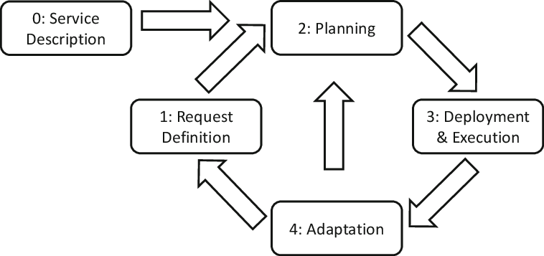

**SIEM**

* SIEM stands for Security Information and Event Management. It is a comprehensive approach to security management that combines two critical functions: Security Information Management (SIM) and Security Event Management (SEM).
* SIEM solutions collect, aggregate, and analyze data from various sources within an organization's IT environment, including logs from systems, applications, network devices, and security controls.
* The primary goal of SIEM is to provide real-time visibility into an organization's security posture and enable effective threat detection, incident response, and compliance management.

**Key Components of SIEM:**

1. **Data Collection:** SIEM solutions collect data from various sources, such as logs from firewalls, intrusion detection systems (IDS), antivirus software, servers, and applications. Data can be collected in real-time or near real-time.
2. **Data Aggregation and Correlation:** The collected data is aggregated and correlated to identify patterns, anomalies, and potential security incidents. Correlation rules help SIEM systems determine if specific events or activities indicate a potential security threat.
3. **Alerting and Incident Detection:** When a security event matches predefined correlation rules or thresholds, the SIEM generates alerts to notify security analysts of potential incidents.
4. **Incident Response and Workflow:** SIEM solutions provide incident response workflows, enabling security teams to investigate and respond to security incidents efficiently.
5. **Reporting and Compliance:** SIEM generates reports and dashboards that provide insights into the organization's security posture, compliance status, and trends in security incidents.
6. **Threat Intelligence Integration**: SIEM systems often integrate with external threat intelligence feeds to enhance the detection of advanced threats and zero-day exploits.

**SIEM Life Cycle:**

The SIEM life cycle consists of several stages:

1. **Planning:** The organization identifies its security requirements, goals, and budget constraints. This stage involves evaluating the scope of the SIEM deployment, defining use cases, and identifying data sources to be integrated.
2. **Design and Architecture**: During this stage, the SIEM architecture is designed to meet the organization's specific needs. Decisions are made on hardware, software, data storage, and scalability requirements.
3. **Deployment**: The SIEM solution is implemented and integrated into the organization's IT environment. Data sources are connected, and the necessary configurations are applied.
4. **Data Collection and Onboarding:** Data sources are onboarded to the SIEM platform, and log data collection begins. This process may involve configuring agents, syslog servers, or APIs to forward logs to the SIEM.
5. **Tuning and Customization:** SIEM correlation rules and alerts are tuned and customized to match the organization's threat landscape and security policies. This step ensures that the SIEM produces actionable and relevant alerts.
6. **Training and Skill Development**: Security analysts and SOC teams are trained on using the SIEM effectively for threat detection, incident response, and compliance reporting.
7. **Operationalization:** The SIEM becomes an integral part of the organization's security operations. Security analysts continuously monitor the SIEM for alerts and respond to potential security incidents.
8. **Maintenance and Updates:** Regular maintenance, software updates, and tuning of the SIEM are performed to ensure its optimal performance and effectiveness.
9. **Continuous Improvement**: Organizations continuously evaluate the SIEM's performance, identify areas of improvement, and enhance its capabilities to address emerging threats and new requirements.
10. **Retirement or Replacement**: As technology evolves and security needs change, organizations may retire or replace their SIEM solution to keep up with the latest security challenges.



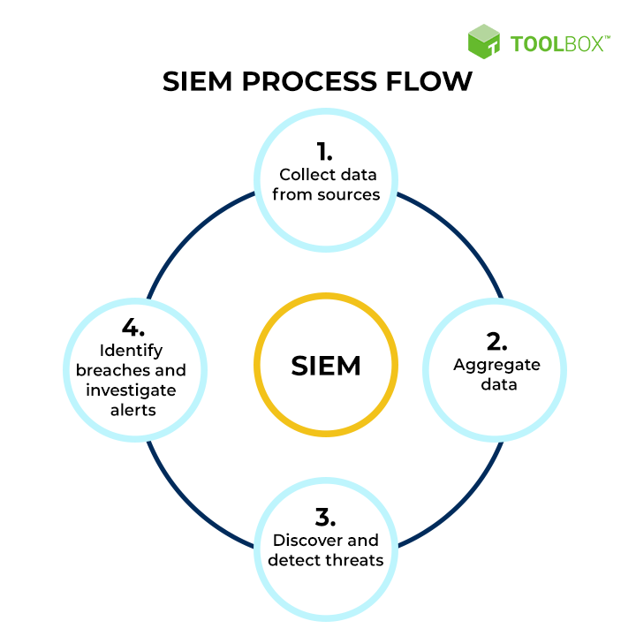

**Five Predictions For The Future Of SIEM** **(Security Information and Event Management):**

1. **AI-Powered Threat Detection and Response:** SIEM solutions will increasingly leverage artificial intelligence (AI) and machine learning (ML) to enhance threat detection and response capabilities. AI algorithms can process vast amounts of security data, identify patterns, and detect anomalies in real-time, enabling more accurate and proactive threat hunting.
2. **Cloud-Native SIEM Solutions:** As organizations continue to migrate their infrastructure and applications to the cloud, SIEM solutions will follow suit. Cloud-native SIEM platforms will emerge, offering more flexibility, scalability, and ease of deployment for cloud-based environments.
3. **Integration with IoT and OT Security:** With the proliferation of Internet of Things (IoT) and Operational Technology (OT) devices, SIEM solutions will need to extend their capabilities to monitor and analyze the security of these devices and networks. Integration with IoT and OT security tools will become crucial for comprehensive threat monitoring.
4. **User and Entity Behavior Analytics (UEBA) Integration:** SIEM solutions will increasingly integrate User and Entity Behavior Analytics (UEBA) to better understand and detect abnormal user behavior. UEBA can provide insights into insider threats, compromised accounts, and other user-related risks.
5. **Automated Incident Response and Orchestration:** SIEM platforms will evolve to include automated incident response and security orchestration capabilities. This means that in addition to detecting threats, SIEM will be able to trigger automated responses or collaborate with other security tools to take immediate action against threats without human intervention.

**MISP - Open Source Threat Intelligence Platform**

A platform for sharing, storing and correlating Indicators of Compromises of targeted attacks but also threat intelligence such as threat actor information, financial fraud information and many more.

MISP - Open Source Threat Intelligence and Sharing Platform allows organizations to share information such as threat intelligence, indicators, threat actor information or any kind of threat which can be structured in MISP. MISP users benefit from the collaborative knowledge about existing malware or threats. The aim of this trusted platform is to help improve the counter-measures used against targeted attacks and set-up preventive actions and detection.

How does MISP work?

Malware Information Sharing Platform is accessible from different interfaces like a web interface (for analysts or incident handlers) or via a ReST API (for systems pushing and pulling IOCs). The inherent goal of MISP is to be a robust platform that ensures a smooth operation from revealing, maturing and exploiting the threat information.

How to request access?

If you work for private organisations, organisations, CERTs, if you are a trusted security vendor or researcher, you can request access by contacting us. The registration and access requires the use of at least one PGP key per organization.

What are the rules?

The access is free-of-charge. The objective is to stimulate sharing practices among public and private actors. The access is mainly bound to distribution as described in the traffic light protocol.

**Threat intelligence :**

Threat intelligence refers to the collection, analysis, and dissemination of information about potential or existing cybersecurity threats. It involves gathering data about various types of cyber threats, including malware, vulnerabilities, attack techniques, threat actors, and indicators of compromise (IoCs), and then converting this data into actionable insights that help organizations protect their systems and data. Threat intelligence helps organizations stay ahead of cyber threats by providing valuable context and information to inform decision-making and enhance their overall cybersecurity posture.

Here are some key aspects of threat intelligence:

**Data Collection:** Threat intelligence involves collecting data from a wide range of sources, including security research reports, security vendors, open-source intelligence, government agencies, industry groups, and proprietary sources.Analysis: The collected data is analyzed to identify patterns, trends, and emerging threats. Analysts work to understand the tactics, techniques, and procedures (TTPs) employed by threat actors.

**Classification:** Threat intelligence is often categorized into different levels based on the level of specificity and relevance. This can include strategic intelligence (high-level trends), operational intelligence (specific threats), and tactical intelligence (technical details).

**Indicators of Compromise (IoCs):** IoCs are specific artifacts associated with a threat, such as IP addresses, domain names, file hashes, and URLs. Threat intelligence provides IoCs that organizations can use to detect and block threats in their environments.

**Threat Actor Profiles:** Threat intelligence provides information about the motivations, capabilities, and characteristics of threat actors and hacking groups. This helps organizations understand potential adversaries.

**Vulnerability Intelligence:** Threat intelligence includes information about newly discovered vulnerabilities in software and systems, helping organizations prioritize patching efforts.Sharing and **Collaboration:** Organizations can share threat intelligence within their industry or sector to collectively defend against common threats. Sharing threat intelligence helps the broader community respond faster to emerging threats.

**Incident Response:**

Threat intelligence supports incident response by providing information that helps organizations identify the extent of a breach, mitigate its impact, and prevent future attacks.

**Proactive Defense:** Threat intelligence allows organizations to proactively identify and address vulnerabilities and threats before they are exploited.

**Security Automation:** Threat intelligence feeds can be integrated into security tools and platforms to automate threat detection and response processes.

**Risk Management:** Threat intelligence assists in understanding the potential risks associated with specific threats, helping organizations allocate resources more effectively.

**Situational Awareness:** Threat intelligence provides a clearer picture of the threat landscape, enabling organizations to make informed decisions about their security strategies.

**Cybersecurity Strategy:** Organizations can use threat intelligence to shape their overall cybersecurity strategies, adapt to evolving threats, and allocate resources appropriately.

Threat intelligence is a dynamic field that requires continuous monitoring of the threat landscape. It's an essential component of modern cybersecurity, helping organizations proactively defend against increasingly sophisticated cyber threats. Incident response Incident response is a structured approach that organizations follow to effectively manage and mitigate the impact of cybersecurity incidents. An incident can include any unauthorized or unexpected event that poses a risk to an organization's IT systems, data, operations, or overall security posture. Incident response aims to minimize damage, restore normal operations, and prevent similar incidents in the future. Create a detailed plan that outlines roles, responsibilities, communication procedures, escalation paths, and specific actions to be taken during different types of incidents. Identify individuals from various departments (IT, security, legal, PR) who will be responsible for different aspects of incident handling.

**Define priorities:** Classify incidents based on their severity and potential impact to prioritize responses.

**Detecting incidents:** Monitor logs, alerts, and security tools to identify unusual activities or signs of a potential incident. Qradar & understanding tool IBM QRadar is a security information and event management (SIEM) solution designed to help organizations detect and respond to security threats and incidents in real-time. It offers advanced capabilities for collecting, analyzing, and correlating security data from various sources to provide insights into potential threats and vulnerabilities.

**How you think you deploy soc in your college**

Deploying a Security Operations Center (SOC) in an organization involves careful planning, resource allocation, and a structured approach.

**Assessment and Requirements Gathering:**

1. Conduct a thorough assessment of the organization's current cybersecurity posture, including existing security measures, tools, and processes.
2. Identify the specific security challenges, risks, and compliance requirements that a SOC will address.
3. Define the goals and objectives of the SOC deployment to align with the organization's overall security strategy.
4. Budget and Resource Allocation: Determine the budget and resource requirements for establishing and maintaining the SOC.

Allocate personnel, hardware, software, and other necessary resources to support the SOC operations.

**Build a Skilled Team:**

* Recruit or assign skilled security professionals to form the SOC team.
* The team should include security analysts, incident responders, threat hunters, and SOC management personnel.

**Infrastructure and Technology Setup:**

* Establish the physical or virtual infrastructure for the SOC, including servers, network equipment, and storage.
* Deploy the required security technologies, such as SIEM,intrusion detection and prevention systems (IDS/IPS), firewalls, endpoint protection, and threat intelligence feeds.

**Integration and Data Collection:**

* Integrate security tools and systems with the SIEM to centralize log and event data collection.
* Ensure that critical data sources, such as firewalls, servers, network devices, and applications, are sending logs to the SIEM.

**Establish Processes and Procedures:**

* Define standard operating procedures (SOPs) for various SOC activities, including incident handling, response protocols, escalation procedures, and communication guidelines.
* Implement incident categorization and prioritization mechanisms.

**Implement Monitoring and Alerting:**

* Configure the SIEM to generate real-time alerts based on predefined correlation rules and security use cases.
* Fine-tune alerting thresholds to minimize false positives and focus on critical alerts.

**Incident Response and Escalation:**

* Develop a formal incident response plan that outlines the steps to be taken in the event of a security incident.
* Define roles and responsibilities for incident handling, and establish a clear escalation path for severe incidents.

**Training and Skill Development:**

* Provide comprehensive training to the SOC team on the use of security tools, incident analysis, threat hunting, and incident response best practices.
* Keep the team updated on the latest cybersecurity trends, attack techniques, and relevant certifications.

**Testing and Continuous Improvement:**

* Conduct regular tabletop exercises and simulated cyber attack scenarios to test the SOC team's response capabilities.
* Use the insights gained from testing to improve and refine the SOC's processes and procedures.

**Monitoring and Reporting:**

* Continuously monitor the SOC's performance and effectiveness in detecting and responding to security incidents.
* Generate regular reports and metrics to measure the SOCs performance and communicate its value to stakeholders.

**Integration with IT and Business Functions:**

* Foster collaboration between the SOC and other IT and business units to ensure a coordinated approach to security.
* Engage with executive management and board members to gain support and buy-in for SOC initiatives
* Deploying a SOC is an ongoing process that requires adaptability and continuous improvement. Regular assessments, training, and updates are essential to ensure that the SOC remains effective in addressing the organization's evolving security challenge.

**Qradar and Understanding about its Tools:**

IBM QRadar is a security information and event management (SIEM) solution designed to help organizations detect and respond to security threats and incidents in real-time. It offers advanced capabilities for collecting, analyzing, and correlating security data from various sources to provide insights into potential threats and vulnerabilities. QRadar is widely used by enterprises and organizations to enhance their cybersecurity posture.

* QRadar collects data from various sources, including network devices, servers, applications, firewalls, and endpoints.
* It supports log and event collection using various protocols, such as syslog, SNMP, and more. QRadar uses advanced correlation techniques to analyze collected data and identify patterns, anomalies, and potential security incidents.
* It correlates events in real-time to provide a comprehensive view of the organization's security posture.
* QRadar employs predefined rules and custom rules to detect suspicious activities and potential threats.
* When a rule is triggered, QRadar generates alerts with details about the detected incident.
* QRadar uses behavioral analytics to identify deviations from normal behavior, helping to detect unknown threats and insider threats.
* The solution provides tools for security analysts to investigate alerts and incidents in-depth. Analysts can use visualizations, search capabilities, and context-rich data to understand the scope and impact of incidents.
* QRadar supports forensic analysis by providing historical data for incidents, allowing analysts to backtrack and understand the sequence of events.
* QRadar offers customizable dashboards and reports that provide insights into security events, trends, and risks.
* Reports can be used for compliance audits, management reporting, and sharing insights with stakeholders.

QRadar integrates with threat intelligence feeds to enhance threat detection and provide context about known threats.

* QRadar can be integrated with other security tools, such as vulnerability scanners, endpoint protection, and identity and access management solutions.
* QRadar supports automation of response actions to quickly mitigate threats.
* It can be integrated with incident response playbooks to streamline response procedures.
* QRadar can analyze user behavior to detect unusual or risky activities.
* QRadar can monitor and secure cloud environments, on-premises systems, and hybrid infrastructures. QRadar provides features to assist organizations in meeting compliance requirements.
* IBM QRadar is a comprehensive SIEM solution that helps organizations detect, respond to, and mitigate cybersecurity threats effectively. Its advanced features, integration capabilities, and user-friendly interface make it a popular choice for organizations seeking to enhance their security operations.

* IBM QRadar is a leading Security Information and Event Management (SIEM) solution designed to help organizations detect, investigate, and respond to cybersecurity threats effectively.
* It provides comprehensive visibility into an organization's security environment by collecting and analyzing data from various sources, including logs, network traffic, and security devices. Here are some key details about IBM QRadar.

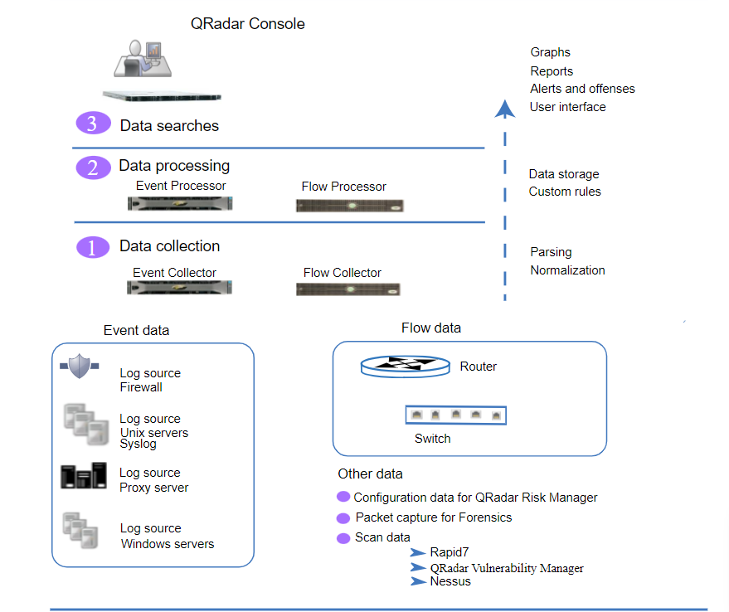

**Key Features and Capabilities:**

1. **Log Management:** QRadar collects and stores logs from various devices, systems, and applications, enabling centralized log management and analysis.
2. **Real-Time Event Correlation:** The platform uses advanced correlation algorithms to detect security incidents by analyzing events from multiple sources and identifying patterns of malicious activity.
3. **Network Traffic Analysis:** QRadar monitors network traffic to detect suspicious behavior, such as unusual communication patterns or data exfiltration.
4. **User and Entity Behavior Analytics (UEBA):** QRadar includes UEBA capabilities to identify abnormal user behavior and potential insider threats.
5. **Threat Intelligence Integration:** The platform integrates with external threat intelligence feeds to enhance threat detection and provide context on emerging threats.
6. **Incident Investigation and Forensics:** QRadar provides tools for incident investigation and forensic analysis, helping security analysts understand the scope and impact of security incidents.
7. **Security Incident Response:** The platform offers automated incident response workflows and integrations with security tools to enable faster response times and remediation.
8. **Compliance Reporting:** QRadar includes pre-built compliance reporting templates to assist with meeting regulatory requirements and security audits.
9. **Anomaly Detection:** The platform uses behavioral analysis and anomaly detection techniques to identify deviations from normal patterns of activity.

**Deployment Options:**

1. **On-Premises Deployment:** Organizations can deploy QRadar on their own infrastructure, allowing them to have complete control over the system and data.
2. **Cloud Deployment:** IBM also offers QRadar on the cloud, providing organizations with the flexibility and scalability of cloud-based SIEM.

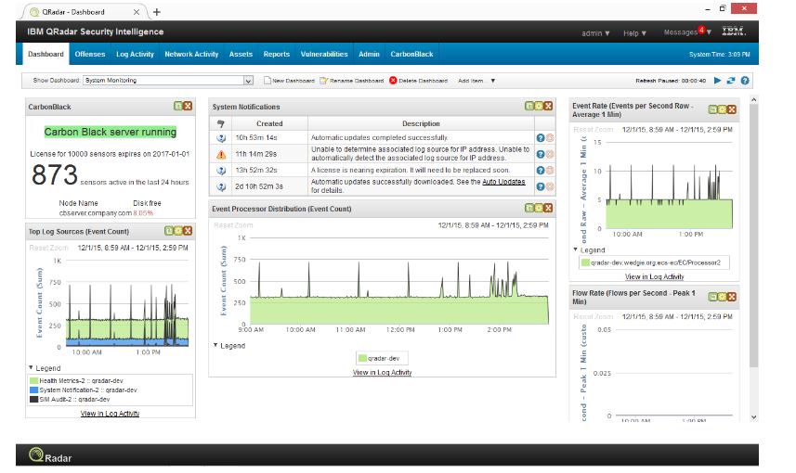

**Figure Name : QRadar dashboard**

**Benefits:**

1. **Centralized Visibility:** QRadar provides a single pane of glass view of an organization's security posture, allowing security teams to monitor and manage security events from a centralized location.
2. **Threat Detection and Response:** By leveraging advanced analytics and correlation, QRadar helps identify security incidents in real-time, enabling faster incident response.
3. **Compliance Management:** QRadar's reporting capabilities assist organizations in meeting compliance requirements and demonstrating adherence to security policies.
4. **Reduced Incident Dwell Time:** The platform's capabilities to detect and respond to threats efficiently help reduce the time between detection and remediation.
5. **Scalability:** QRadar can scale to handle large amounts of security data and event logs, making it suitable for organizations of all sizes.
6. **Integration Ecosystem:** QRadar offers an extensive integration ecosystem with other security tools, allowing organizations to create a comprehensive security architecture.

**Conclusion:**

**Stage 1:**  Maintain a proactive approach to security by continuously monitoring and analyzing the data collected by Qradar. This allows us to quickly detect any anomalies or suspicious activities and respond promptly to mitigate potential risks. Use the insights gained from monitoring and analysis to improve security operations and strengthen your organization's defenses.

**Stage 2 :**  Nessus is a widely used vulnerability assessment tool developed by Tenable Network Security. It is designed to identify and assess vulnerabilities in computer systems, networks, and applications. Nessus helps organizations identify potential security weaknesses in their IT infrastructure by conducting comprehensive scans and providing detailed reports on identified vulnerabilities

**Stage 3 :**  A SoC typically uses a combination of technology, processes, and skilled security analysts to monitor network traffic, system logs, and other data sources for signs of unauthorized access, malicious activity, and potential vulnerabilities. When a potential security threat is detected, the SoC takes appropriate actions to investigate, contain, and remediate the threat. SIEM is a comprehensive approach to cybersecurity management that combines security information management (SIM) and security event management (SEM) into a single solution. SIEM systems provide a centralized platform for collecting, analyzing, correlating, and responding to security related data from various sources across an organization's IT environment

IBM QRadar is a robust and well-established SIEM solution that has earned a reputation for its capabilities in threat detection, incident response, and compliance management. Its advanced analytics and ability to integrate with various security tools make it a popular choice for organizations seeking to strengthen their cybersecurity defenses.

**Topics explored :**

* **Qradar**
* **SIEM**
* **SOC**
* **Vulnerability detection**
* **Cyber security**
* **OWASP**

**Tools explored :**

* **Qradar**
* **VirtualBox**
* **Nessus**